Lab 7 – Exception

Question 1:

Source Code

Leaderboard

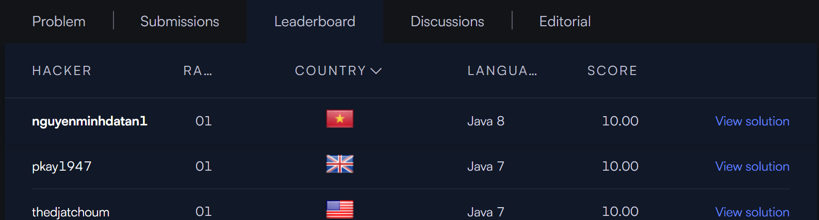

Question 2:

Source Code

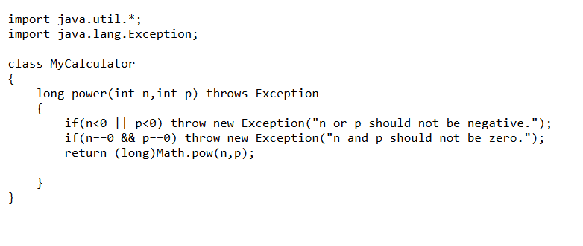

Leaderboard

Question 3:

Source Code

Output

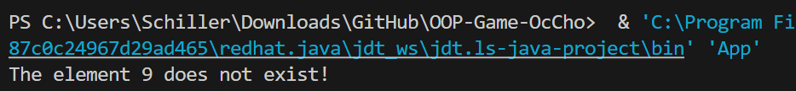

Question 4:

Source Code

Output

